KidzCoding Hour of Code - Apple Clicker

Activity:

Today we are creating a game in which you are trying to click as many apples as you can

Learning Objectives:

* Learn how to use random position function
* Learn how to use wait function
* Learn how to create clones and manipulate them

Materials:

* Finished project: <https://scratch.mit.edu/projects/876898894>
* Starter project: <https://scratch.mit.edu/projects/879594730>

Coding Time!

Step one: Create “Score” variable and beginning the cloning process

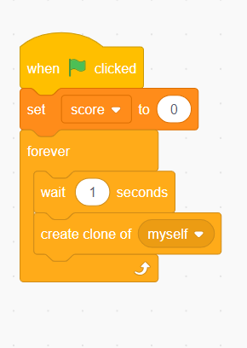

1. **Delete the main sprite and add the apple sprite. Make sure to select it because you are coding this sprite**
2. **then create a variable and call it score**
3. **Next, make it so that the score is set to zero after the program is run**
4. **Then create a loop that creates a clone every second (or whatever time period you choose)**

**Step two: add “when I start as a clone” block and randomizing clone position**

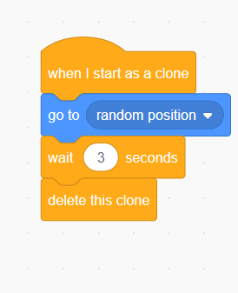

* **Add when I start as clone block**
* **Next make it so that the clone goes to a random position**
* **Make it so that after a few seconds, the clone is deleted**

**Step three: add clicking feature**

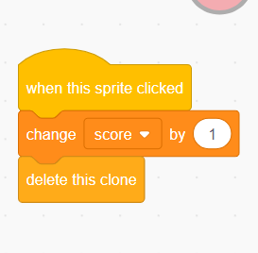

* **Add “when this sprite is clicked” block**
* **Make it so that when the sprite is clicked the score is changed by one and the clone is deleted**

Congratulations, you have just completed an Hour of Code!

Feel free to mess around with the code to make it suitable for your intentions